## 2. NEN 7510 Compliance for Log360

Tagline– Automate compliance with the Dutch NEN 7510 healthcare security standard using Log360.

Overview: The NEN 7510 Compliance extension for Log360 helps healthcare organizations and enterprises align with the Dutch NEN 7510 security framework. By integrating this extension, IT and security teams gain deep visibility into their security posture across all critical healthcare data protection controls.
Log360 continuously collects and correlates log data from Active Directory, Windows, Unix/Linux, Microsoft 365, cloud platforms, and network devices, mapping events directly to NEN 7510 requirements. Security teams can track compliance status in real time, investigate incidents quickly, and generate audit-ready reports with a single click.

Key Features:
- Generate comprehensive audit-reports mapped to each of the NEN 7510 healthcare security controls.
- Provides powerful search capabilities with filters, keywords, and time-based queries for forensic analysis.
- Securely stores and archives logs for customizable retention periods ensuring tamper-proof compliance documentation.
- Configure threshold-based alerts for critical NEN 7510 events and receive notifications via email, SMS, or integrated ticketing systems.

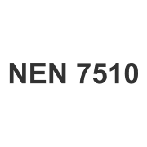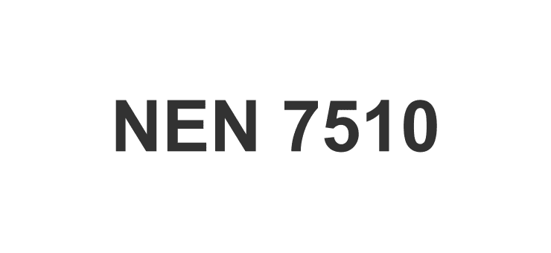

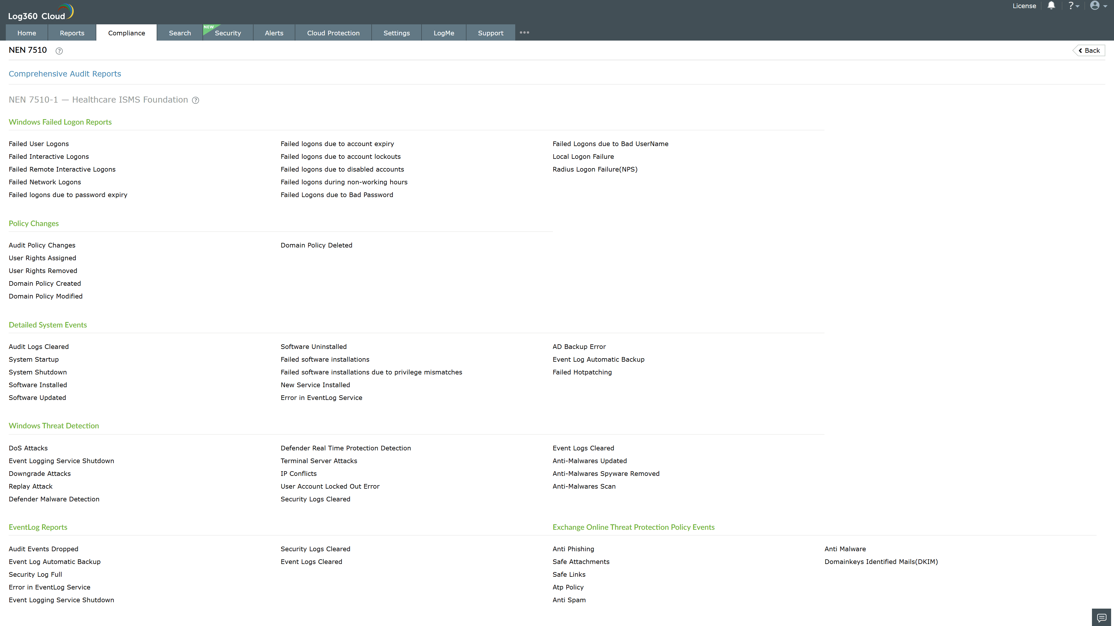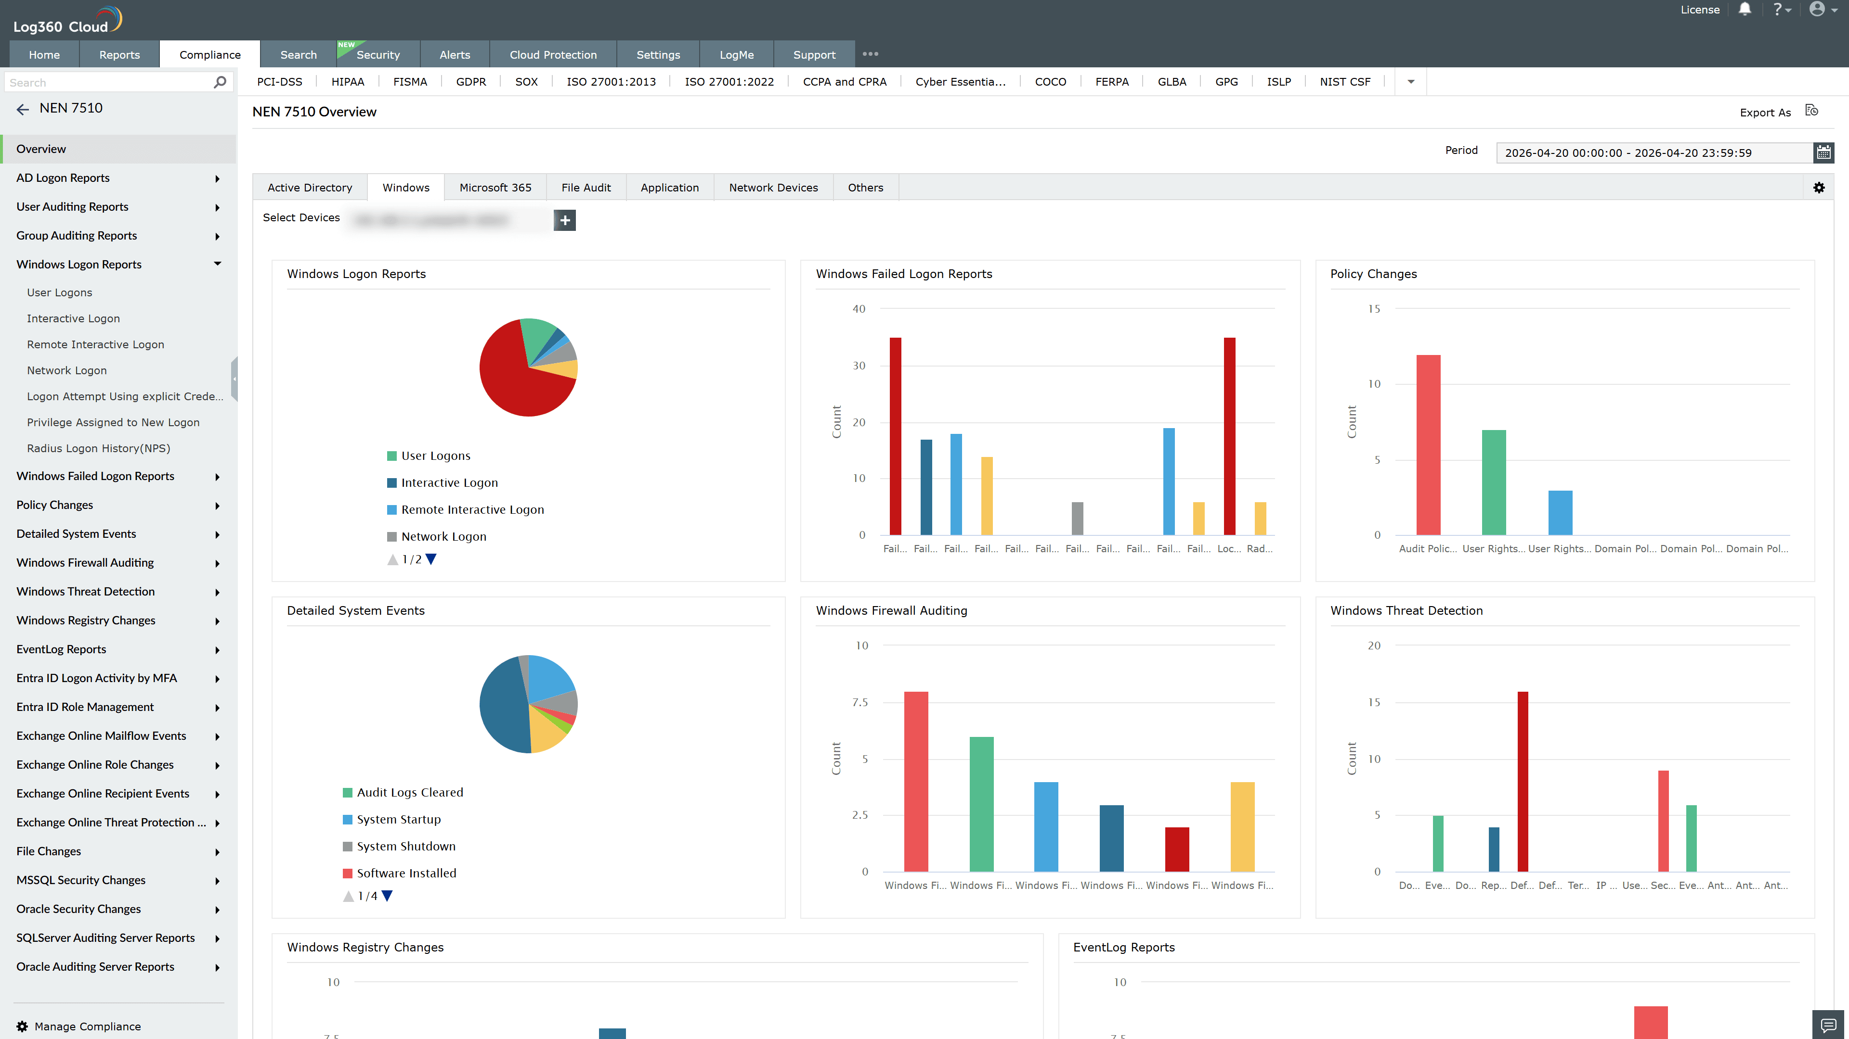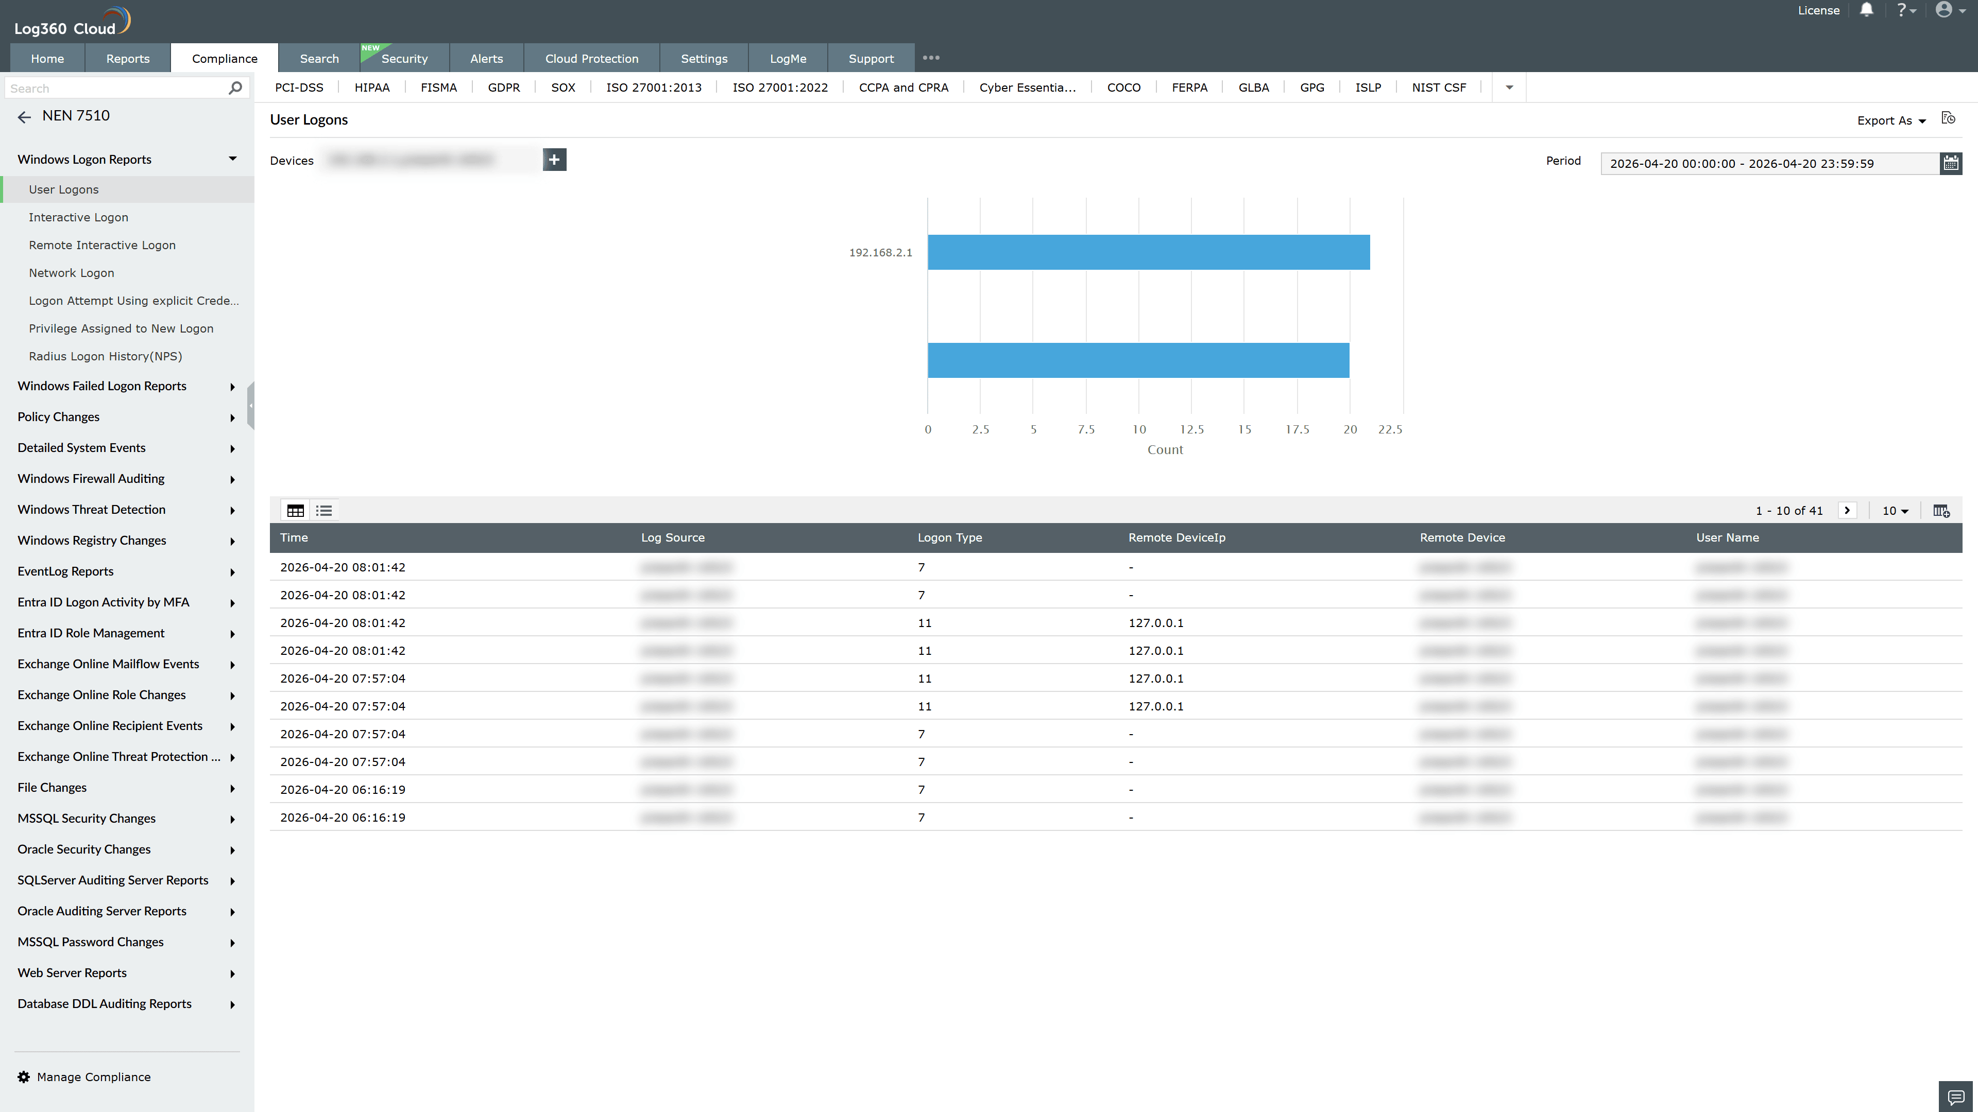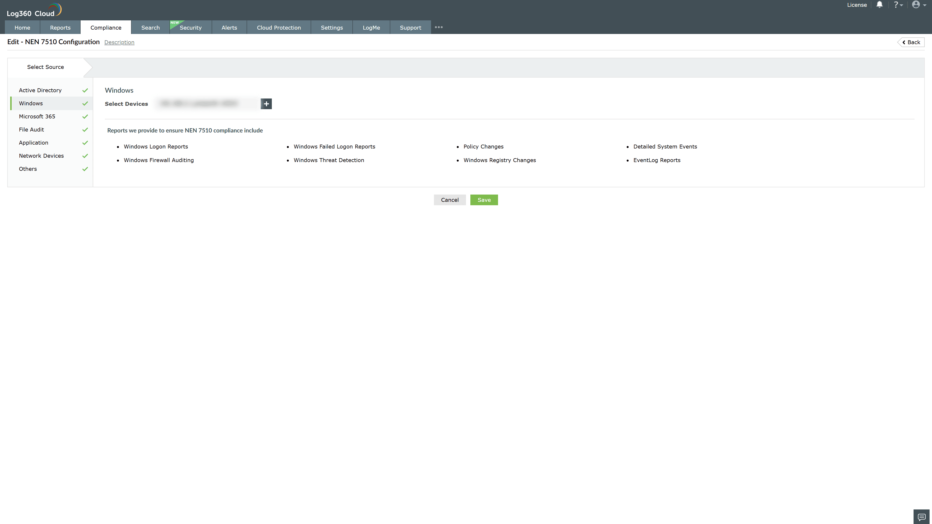

Valid Submission : Yes
Supported Editions : Free, Basic, Standard, Professional, MSSP
Help Document : https://www.manageengine.com/log-management/help/integrations/compliance-extensions.html
Help Video : Not provided
Tags : Log360, Compliance, Privacy monitoring, Data privacy, Regulatory compliance
Supported DCs : US, IN, JP, CA, AU, UK and EU
Privacy Policy:
Terms of Service:
Release Notes:
Predefined reports for the NEN 7510 Compliance.

